Sand Art

Sand Benders

Team 206

Mannat Rana, Cree Hutcherson, Ben Levine, Olivia Pinkowski

May 4, 2020

Arizona State University

EGR 314: Embedded Systems Design II

Dr. Shawn Jordan

# Table of Contents:

**Problem Definition** **3**

Final Problem Statement: 3

Final Customer Impact Statement: 3

Specifications: 4

**Team Member Accomplishments** **5**

Mannat Rana 5

Olivia Pinkowski 5

Ben Levine 6

Cree Hutcherson 6

**Hardware Design Narrative** **8**

Detailed Hardware Description 9

Final Major Component Selection Rationale and Microcontroller Selection Rationale 10

Signal Generator 10

Crystal Oscillator 11

Audio Exciter 12

Driving Circuit 13

Cooling Fan 14

Lid Sensor 15

ADC 16

12V Power Supply 17

3.3V Regulator 17

PIC Microcontroller Selection 18

Power Budget 20

**Software Design Narrative** **22**

Software Design 22

Software Design Rationale 23

**Mechanical Design Narrative** **24**

Mechanical Design Rationale 24

Project in Context 25

Project Photos 26

**Version 2.0 and Lessons Learned** **27**

Hardware Design 27

Software Design 27

Mechanical Design 28

Lessons Learned 29

Recommendations for Future Students 30

**Appendix** **31**

A. Benchmarking 31

B. Bill of Materials 32

C. Final PCB Layout 33

D. All of the Code 34

E. User’s Manual 39

Basic operation with photos 39

Maintenance and troubleshooting 40

F. CAD Model 41

# Problem Definition

## Final Problem Statement:

The purpose of our project is to create a fun, entertaining environment for families to come, enjoy, and learn about frequency vibrations at the robotic art exhibit at the I.D.E.A Museum through an interactive sand table display.

## Final Customer Impact Statement:

Our device will contribute to bringing joy to museum-goers on a daily basis. It will utilize frequency vibrations to manipulate sand into artistic shapes. The participants have the opportunity to mix different colored sand to then place in the device and watch the art form. They then have the opportunity to take their sand mixture home with them. Unfortunately, some of the frequencies used to provide the images do cause noise to be produced and that can become annoying. Sand is also rather difficult to contain when participants are manipulating it but clean up is as easy as vacuuming.

## 

## Specifications:

|  |  |  |  |  |  |  |
| --- | --- | --- | --- | --- | --- | --- |
| **Metric No.** | **Metric** | **Unit** | **Marginal Value** | **Ideal Value** | **Actual Value** | **Evidence and Discussion** |
| 1 | Upper Noise Limit | dB | <120 | <100 | 90 | **Hardware:** N/A  **Software:** N/A  **Mechanical:** The audio exciter is securely tied down and contained which helps in dampening the noise. |
| 2 | Display Time | sec. | <60 | <30 | 20 | **Hardware:** N/A  **Software:** N/A  **Mechanical:** The audio exciter is mounted to be very stable and is able to vibrate the plate efficiently enough to create a pattern in a short time. |
| 3 | Run Time | min. | >10 | >30 | 60 | **Hardware:** With the cooling fan attached, the system has enough thermal management to keep the system in an operable temperature for about an hour even after an hour of vibration.  **Software:** N/A  **Mechanical:** N/A |
| 4 | Amount of Sand/Sugar | lb | <0.5 | <0.2 | 0.75 | **Hardware:** N/A  **Software:** N/A  **Mechanical:** The audio exciter is able to handle about 3/4lb of sugar before its performance is noticeably affected. |
| 5 | Learning Techniques Implemented | # | >1 | 4 | 2 | **Hardware:** N/A  **Software:** N/A  **Mechanical:** Viewers will experience the Holistic Flow and some aspects of the Multiple Intelligences theories as they watch the sand move inside the box |
| 6 | Weight of Product | lb | <200 | <50 | 11.07 | **Hardware:** N/A  **Software:** N/A  **Mechanical:** The system is very lightweight and portable as the containment is cardboard. |
| 7 | Creatable Patterns | # | 1 | 2 | 2 | **Hardware:** The waveform generator is able to send square waves of 2 different frequencies to the audio exciter.  **Software:** The code is able to program the waveform generator to create two different output frequencies.  **Mechanical:** N/A |
| 8 | Time to Clean | min | <30 | <10 | 5~7 | **Hardware:** N/A  **Software:** N/A  **Mechanical:** The project is fairly easy to clean, however, the time can range from how long the device was operated as there will be more displaced sugar with time. |

# Team Member Accomplishments

## Mannat Rana

I was the lead on the PIC Microcontroller subsystem. I designed the supporting circuitry needed for its operation and designed the in-circuit programming so that the SNAP header could be used to program the PIC without having to remove it from the board. I played a heavy role in the team’s documentation during the earlier parts of the semester. I helped many of my teammates create their schematics and PCBs, and also played a role as the middleman for package deliveries for my team once the pandemic began. I also helped heavily in making sure that the team PCB was functional. I helped in detecting and removing the shorts as well as fixing any continuity issues that were found. Throughout the process, I also ended up becoming the main programming lead for the project. I helped make the audio exciter work by making and testing the code needed for the SPI communication to successfully program the AD9833 chip. I aided in the coding of the force sensor subsystem by helping my teammate with reading the SPI data coming from the external ADC. I also helped to get the EUSART communication working between the PIC and Argon by optimizing and tweaking delays and other factors that were affecting the operation time and causing the EUSART to not function as intended. After all the subsystem testing was completed, I also wrote the code that caused the interaction between all of the subsystems. In addition, I tested and coded the timer interrupt so that the patterns that were displayed on the plate were constantly changing.

## Olivia Pinkowski

I was the lead on the audio exciter subsystem and the team’s lead for mechanical and hardware design. I designed the supporting circuitry for the waveform generator and the driving circuit, using an h-bridge to power the audio exciter. My waveform generator, AD9833, took an SPI input to determine the frequency output of the square wave. That signal drove the h-bridge, LM298, which merged the low logic voltage of 3.3V with the 12V supply to have the exciter move the sugar. I built my system to handle the extreme heat that the h-bridge would produce at 40W, even though we never reached that maximum. I became the team lead on the mechanical and hardware designs when the pandemic set in and I still had access to good equipment and campus. This allowed me to properly solder the team PCB, including modified reflow, and pick up parts. I helped my teammates get their individual subsystems working and then helped troubleshoot the final board and presentations. I was able to identify shorts within the team board and repair them to a functional state. Since I had the project, I was also tasked with the mechanical design. Unfortunately, due to the severity of the COVID-19 pandemic, all machines were dedicated to helping build protective equipment. As a result, we were unable to form a true exterior and stand for the project. With help from the TA’s and teammates, I was able to program my chip to have the exciter produce different images and it all worked together for a successful project.

## Ben Levine

I was the lead on the sensor subsystem required for the project. The sensor used was a force-sensitive resistor and it transmitted data through an external ADC to the PIC via SPI communication. The force sensor was designed to act as a means to determine if the lid of the enclosure was opened or closed. In the case where the lid was closed, data would be sent to the microcontroller saying that it was safe to vibrate the plate and display patterns. In order to communicate through SPI, I needed to learn byte-shifting operations to analyze the 8 bits of data sent from the external ADC. The Curiosity Nano used for subsystem testing and final PIC microcontroller could only read 8 bits of data at a time and the ADC sent a total of 16 bits, with four leading and four trailing zeros. In order to find the correct data being sent from the ADC, the byte-shifting operation swapped the first four binary values with the second four, and then the two sets were compared. I also played a role in acquiring parts after the university shut down and was in communication with the Peralta Lab to receive the surface-mount capacitors and resistors needed for team and individual subsystem boards. I was able to connect to the Particle Argon to read the EUSART communication explaining whether the lid was opened or closed for the final design. This allowed us to verify that the ADC was communicating with the PIC, which was also connecting to the Argon.

## Cree Hutcherson

I was the lead on the WiFi subsystem. The device used for communication to our PIC microcontroller over WiFi was a Particle Argon. I configured the Buddy System code for the Argon in the event we were still required to connect to another team. By learning and configuring the Buddy System code, I was able to send and interpret a signal from my Argon to another Argon. This aided in coding the PIC to Argon communication through EUSART. I coded the Argon to interpret the signal sent from the force sensor to the PIC to determine if the lid of our project was open or closed. Once detected, the Argon would output “Lid Status: Closed” while the project was running or have no output if the lid was open. By adding delays to the main code, the EUSART communication was able to output what it was coded to do. I troubleshoot the code using the Curiosity Nano to send code back and forth between it and the Argon to learn how to code microcontroller to Argon communication. I also coded the Nano to light the LED on the Argon when the onboard Nano button was pressed. This was another way to ensure communication between the two devices. In coding the Nano and Argon together, this also added to my knowledge of coding communication between two devices. I aided in troubleshooting my Argon and the team Argon by having the device do a firmware update when needed. By finding the process to put the Argon in DFU (device firmware upgrade) mode and running through the necessary commands to update it.

# Hardware Design Narrative

***Final Electrical Block Diagram***

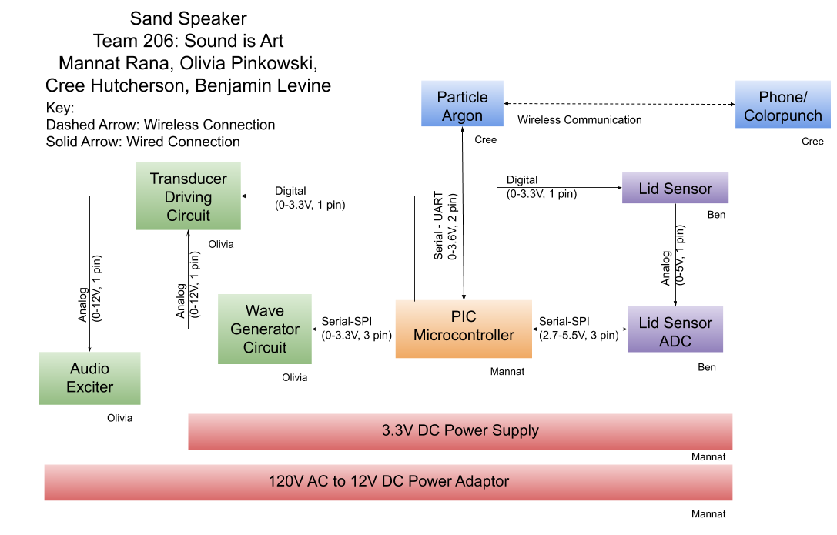

## 

## Detailed Hardware Description

The device operates with two power rails. The first of which is the 12V power rail which is provided to the board through a barrel connector originating from a wall outlet. The 12V rail is used to drive the audio exciter so it has enough power to create the images out of sugar. The h-bridge married the low voltage logic with the higher 12V power rail to control the Audio Exciter. The Audio Exciter could run on a lower voltage but then would not have enough power behind it to vibrate the plate and cause the images to form, thus the 12V supply was optimal to operate at. As you can see by the block diagram, the h-bridge has both the 3.3V and 12V lines running through it, allowing it to properly operate. The second power source is a 3.3V rail. The 3.3V rail is responsible for powering all of the sensors and the PIC microcontroller. The 3.3V rail is provided by the 3.3V regulator that converts the 12V to 3.3V. The PIC microcontroller is responsible for the sending and reception of all the data. The lid sensor subsystem is designed to read the voltage off of a resistive force sensor. The more force applied the more voltage that passes through it. The sensor is given 3.3V from the microcontroller when a reading is to be made. The 3.3V passes through the sensor, and the remaining voltage goes to the external ADC. When a reading is needed, the PIC microcontroller will ground the slave select of the external ADC, and the external ADC will then send the data to the PIC microcontroller. The Particle Argon subsystem is connected through UART. The TX pin on the PIC microcontroller is connected to the RX pin on the Particle Argon, and the RX pin on the PIC microcontroller is connected to the TX pin on the Particle Argon. The Particle Argon receives its power from the 3.3V rail. The PIC is able to send the Particle Argon data, and the Particle Argon can then interpret that data, and output data wirelessly to another wireless device, such a computer, phone, or team project also utilizing a Particle Argon. The audio exciter circuit has many components. The first step is the connection between the PIC Microcontroller and the waveform generator circuit. The PIC Microcontroller will communicate to the waveform generator through SPI. When the frequency needs to be changed, the PIC Microcontroller will drop the slave select of the waveform generator to ground. It will then program the waveform generator through SPI. The waveform generator will then send the desired waveform with the desired frequency to the h-bridge. However, the PIC Microcontroller controls the enable pin of the h-bridge, thus, the frequency will only be sent to the audio exciter when the PIC microcontroller powers the enable pin on the h-bridge. 12V is sent from the h-bridge to the audio exciter in the waveform sent from the waveform generator when the enable pin is set high, and no voltage is sent to the audio exciter when the enable pin is set low.

## 

## Final Major Component Selection Rationale and Microcontroller Selection Rationale

### Signal Generator

|  |  |  |
| --- | --- | --- |
| **Solution** | **Pros** | **Cons** |
| Option 1.  AD9833 Programmable Waveform Generator  $10.04/each  [Link to AD9833](https://www.analog.com/en/products/ad9833.html#product-overview)  [Link to purchase](https://www.digikey.com/products/en?mpart=AD9833BRMZ&v=505) from DigiKey | * 2.2V - 5.5V supply * Surface-mount * 0-25MHz range * Thorough datasheet * 10-bit Resolution * No external hardware required * Can ship immediately * SPI programmable | * Package only offered as surface mount * The component is expensive by comparison |
| Option 2.  SI5351A-B04486-GT Signal Gen  $0.92/each  [Link to SI5351 from DigiKey](https://www.digikey.com/product-detail/en/silicon-laboratories-inc/SI5351A-B04486-GT/336-3529-5-ND/5799560?utm_adgroup=Integrated%20Circuits%20(ICs)&utm_source=google&utm_medium=cpc&utm_campaign=Shopping_Silicon%20Labs_0336_Co-op&utm_term=&utm_content=Integrated%20Circuits%20(ICs)&gclid=Cj0KCQiAvc_xBRCYARIsAC5QT9mDKf2_thJayTZ9zF58J0-ThcJFOth0LTHSorKj4T9Nr1twakaC4vUaAjrsEALw_wcB) | * 2.5V-3.3V Power Supply $I^{2}C$* user-definable configuration * Surface Mount * Can ship immediately | * 2.5kHz-200MHz * Can only store 8 frequencies |
| Option 3.  UC2901D Signal Generator  $7.31/each  [Link to UC2901 from DigiKey](https://www.digikey.com/product-detail/en/texas-instruments/UC2901D/296-11204-5-ND/381695?utm_adgroup=PMIC%20-%20Power%20Management%20-%20Specialized&utm_source=google&utm_medium=cpc&utm_campaign=Shopping_Integrated%20Circuits%20%28ICs%29_NEW&utm_term=&utm_content=PMIC%20-%20Power%20Management%20-%20Specialized&gclid=CjwKCAiAg9rxBRADEiwAxKDTusnDaMenJSBDC2A5O2FEGZBoXTXzw06z-_BtZx7ui8HZ6hy5XgczrxoC6ekQAvD_BwE) | * 0-5MHz * 4.5V-40V Power Supply * 5mA supply * Surface Mount * Can ship immediately | * Requires extra circuit components * Package only offered as surface mount |
| Option 4.  MAX038CPP High-Frequency Waveform Generator  No price available  [Link to from MAX038CPP DigiKey](https://www.digikey.com/product-detail/en/maxim-integrated/MAX038CPP/MAX038CPP-ND/141034) | * 0.1-20MHz * 4.75-5.25V Power Supply * Can produce Triangle, Sawtooth, Sine, Square, and Pulse Waveforms | * Not available to ship * Not Surface Mount |
| Option 5.  MC12080DG Frequency Gen  $5.04/each  [Link to MC12080 from DigiKey](https://www.digikey.com/product-detail/en/on-semiconductor/MC12080DG/MC12080DGOS-ND/918848?utm_adgroup=Clock%2FTiming%20-%20Clock%20Generators%2C%20PLLs%2C%20Frequency%20Synthesizers&utm_source=google&utm_medium=cpc&utm_campaign=Shopping_Integrated%20Circuits%20%28ICs%29_NEW&utm_term=&utm_content=Clock%2FTiming%20-%20Clock%20Generators%2C%20PLLs%2C%20Frequency%20Synthesizers&gclid=CjwKCAiAg9rxBRADEiwAxKDTurGzz0XlSnRn6A8TGCYmc-evqKvkbiaioin7fxwHko9UzA23fs-2vhoCgxgQAvD_BwE) | * 4.5-5.5V * 1.1 GHz toggle Frequency * Surface Mount | * External Hardware required * The datasheet is not very extensive |
| Option 6.  ADF4002BCPZ-RL7  $2.33/each  [Link to Generator](https://www.digikey.com/product-detail/en/analog-devices-inc/ADF4002BCPZ-RL7/ADF4002BCPZ-RL7TR-ND/1118697) | * 0-400MHz bandwidth * 2.7-3.3V Power Supply | * Only available in large quantities * The package is very small |

**Choice:** Option 1: AD9833 Programmable Waveform Generator.

**Rationale:** The team will be utilizing the AD9833 because it has the largest effective frequency range and it can operate in the largest range of power, so regardless of fluctuations the chip will still work. This chip also does not require additional hardware to function.

### Crystal Oscillator

|  |  |  |
| --- | --- | --- |
| **Solution**  FNETHE025  Option 1  $1.10  [Link to Oscillator](https://www.digikey.com/product-detail/en/diodes-incorporated/FNETHE025/FNETHE025CT-ND/2273412) | **Pros**   * The stability is $±25ppm$* Has a load of 15 pF * 25MHz frequency * 3.3V source * Source Amperage: 10µA | **Cons**   * Requires external Capacitor * Reflow required |
| XLH536025  Option 2  $1.26  [Link to Oscillator](https://www.digikey.com/product-detail/en/renesas-electronics-america-inc/XLH536025.000000I/631-1156-1-ND/2074684) | * The stability is $±25ppm$* Has a load of 15 pF * 25MHz frequency * 3.3V source | * Requires external Capacitor * Etra pins |

**Choice**: Option 1

**Rationale**: There are fewer pins to deal with and the package will be able to be soldered and dealt with. This option is slightly cheaper as well.

## 

### Audio Exciter

|  |  |  |
| --- | --- | --- |
| **Solution** | **Pros** | **Cons** |
| Option 1.  Mechanical Wave  Driver SF-9324  $185/each  [Link to Wave Driver](https://www.pasco.com/products/lab-apparatus/waves-and-sound/ripple-tank-and-standing-waves/sf-9324) | * 2.2V - 5.5V supply * Variable-frequency * Variable-amplitude * Mechanical vibrations * 0.1 to 5000 Hz * Requires a function generator with a minimum of ±8 V at 0.5 A | * Beyond our budget * Not a lot of documentation to supplement the information * No datasheet provided |
| Option 2.  Mechanical Wave Driver  $135/each  [Link to Mechanical Driver](https://www.arborsci.com/products/mechanical-wave-driver?variant=18112159449161&utm_medium=cpc&utm_source=google&utm_campaign=Google%20Shopping&gclid=CjwKCAiAg9rxBRADEiwAxKDTuuFJjRqeKwG8eX10HqAW9CqO0N595upbMt79mSmO7Q4sx06dGsC_vRoCV3sQAvD_BwE) | * Plays the whole audio frequency * Provide variable frequency * Variable-amplitude and mechanical vibrations | * Requires Sine Wave Generator P7-2000 * No datasheet provided |
| Option 3.  ASX07008-WP-R Transducer  $23.81/each  [Link to the Transducer](https://www.mouser.com/ProductDetail/PUI-Audio/ASX07008-WP-R?qs=%2Fha2pyFadugEGfSbvQ2w3yNVd4dhjGto8LgrsEKy0GA%3D) | * 5-10W system * 0-10.5kHz * 12KHz Rezonance * PUI Audio Input | * The datasheet is not very detailed * 12-week lead time |
| Option 4.  ASX07008-WP-R Audio Exciter  $26.63/each  [Link to exciter](https://www.digikey.com/product-detail/en/pui-audio-inc/ASX07008-WP-R/668-1564-ND/6125077) | * 5-10W System * Simple interface | * 1.2K-10KHz * The datasheet is not very detailed |
| Option 5.  Dayton Audio  DAEX32QMB $26.69/each  [Link to Audio Exciter](https://www.amazon.com/Dayton-Audio-DAEX32QMB-4-Quad-Exciter/dp/B071LH266V/ref=sr_1_fkmr0_1?keywords=audio+exciter+15W&qid=1580702560&sr=8-1-fkmr0#feature-bullets-btf)  [Link to site with datasheet](https://www.parts-express.com/dayton-audio-daex32qmb-4-quad-feet-mega-bass-32mm-exciter-40w-4-ohm--295-264?gclid=CjwKCAiAg9rxBRADEiwAxKDTuuIQHHcXOdB6KtV0kseEbXMdIli8O_LharOcnyaJESLJe1GjQCsnDxoCOgcQAvD_BwE) | * 0-20KHz range * 32mm Exciter * 40W * 4 Ohm impedance | * The datasheet is not too detailed * No leads |

**Choice:** Option 5: Dayton Audio DAEX32QMB

**Rationale:** The team will utilize the Dayton Audio DAEX32QMB audio exciter. The device can be bought on amazon and the datasheet has been found. The device has the specified range to display the most images with and the system will be strong enough to produce a large image in the sand.

### Driving Circuit

|  |  |  |
| --- | --- | --- |
| **Solution** | **Pros** | **Cons** |
| Option 1.  DRV8876RGTR H-Bridge Driver  $1.78/each  [Link to H-Bridge](https://www.digikey.com/product-detail/en/texas-instruments/DRV8876RGTR/296-DRV8876RGTR-ND/11308784) | * 4.5-37V operating supply voltage range * Supports 1.8V, 3.3V, and 5V logic inputs * Has a thermal shut down * Overcurrent protected | * It only handles the 3.5A and the variation that handles 6A is unavailable * Unavailable in through-hole |
| Option 2.  MP6519GQ-P H-Bridge  $3.11/each  [Link to H-Bridge](https://www.digikey.com/product-detail/en/monolithic-power-systems-inc/MP6519GQ-P/1589-MP6519GQ-PCT-ND/10431229) | * 2.5-28V Power Range * Up to 5A Output Load Current * 30kHz to 300kHz Programmable SwitchingFrequency * Over-Temperature Shutdown | * Available in a QFN-19 (3mmx3mm) Package (Very small) * Only takes logic from 1.5V line |
| Option 3.  L298P013TR H-Bridge  $5.83/each  [Link to the H-Bridge](https://www.digikey.com/product-detail/en/stmicroelectronics/L298P013TR/497-3624-1-ND/677613) | * 0-46V Power Supply * Up to 4A * Comes in both surface and through-hole | * Logic Voltage <1.5V * Will require a heat sink |

**Choice:** Option 3: L298P013TR H-Bridge

**Rationale:** The team will use the L298 in its surface-mount package. Two members have already worked with the through-hole variant and the driver meets the specs it needs to. The device will be simple to code.

### 

### Cooling Fan

|  |  |  |
| --- | --- | --- |
| **Solution** | **Pros** | **Cons** |
| Option 1.  GM0503PHV2 30mm Fan  $8.99/each  [Link to Fan](https://www.amazon.com/SUNON-Brushless-Cooling-x15mm-GM0503PHV2-8/dp/B06WW9G2FL) | * 5V Power Supply * .4 W System | * No Datasheet * Small Dimensions- will move less air |
| Option 2.  FBL09A12H1A Fan  $5.06/each  [Link to Fan](https://www.digikey.com/product-detail/en/nmb-technologies-corporation/FBL09A12H1A/P10900-ND/286430) | * 7-13.8 V Power Supply * Square - 92mm L x 92mm H Hydro-wave (HWB) * Airflow: 56.8 CFM (1.59m³/min) * 2.7W System | * Limited Information in Datasheet * Has a life expectancy of 50000 Hrs |
| Option 3.  FAD1-04010BSAW11 Fan  $1.27/each  [Link to Fans](https://www.digikey.com/product-detail/en/qualtek/FAD1-04010BSAW11/FAD1-04010BSAW11-ND/2600684) | * 5V Power Supply * 250mW * Life: 70,000 Hours | * Airflow: 3.3 CFM (0.092m³/min) * It’s all plastic |
| Option 4  FAD1-04010BBLW11 Fan  $5.83/each  [Link to Fan](https://www.digikey.com/product-detail/en/qualtek/FAD1-04010BBLW11/Q608-ND/2600052) | * 5 Volt System * Airflow 4.2 CFM (0.118m³/min) | * Plastic * 350mW |

**Choice:** Option 4: FAD1-04010BBLW11 Fan

**Rationale:** The team will use the FAD1-04010BBLW11 Fan because it moves the most air efficiently despite being made of plastic. The fan will be required in order to keep the PCB cool while the driver and transducer are running. The system will easily fit within the 5V system.

### Lid Sensor

|  |  |  |
| --- | --- | --- |
| **Solution**    FlexiForce  A101 Sensor  Option 1  $39.40 for 4  [Link to Sensor](https://www.tekscan.com/products-solutions/force-sensors/a101?tab=electronics) | **Pros**   * Comes in a pack of 4 so it can be quickly replaced if broken * Registers force up to 44N * Can endure at least 3 million actuations | **Cons**   * It has a very small sensor area * Limited datasheet |
| 30056  Option 2  $24.99  [Link to Sensor](https://www.digikey.com/product-detail/en/parallax-inc/30056/30056-ND/1774430) | * Measures up to 25lbs * Also contains 220ohm resistor, 0.1uF capacitor, and 0.01uF capacitor | * Meant to be a demonstration kit * Limited datasheet |
| Square Force-Sensitive Resistor (FSR) - Interlink 406  Option 3  $8.95  [Link to Sensor](https://www.adafruit.com/product/1075?gclid=EAIaIQobChMIotHyruC05wIVaB-tBh03TwjkEAQYASABEgJbePD_BwE)  [Link to sensor from Digikey](https://www.digikey.com/products/en/sensors-transducers/touch-sensors/971?k=FSR%20406) | * Inexpensive * Tested to 10 million actuations * Detailed datasheet | * Measures up to 20N * Large surface area |
| Force-Sensing Resistor: 0.2″-Diameter Circle  Option 4  $5.95  [Link to Sensor](https://www.pololu.com/product/1695) | * Detailed datasheet * 5mm sensor area | * Can only measure up to 20N * Datasheet contains several of the same series of FSR but does not state variances among parts |

**Choice:** Option 4: Force-Sensing Resistor: 0.2”-Diameter Circle

**Rationale:** This FSR is the same series as the square FSR but in a smaller package. Instead of having a large square sensing area, the slimness of the FSR will allow it to rest on the top of the box and be in direct contact with the lid for the entire time it is closed.

# 

## 

### ADC

|  |  |  |
| --- | --- | --- |
| ADS7868IDBVR  Option 1  $1.55  [Link to ADC](https://www.digikey.com/product-detail/en/texas-instruments/ADS7868IDBVR/296-41406-1-ND/5222649) | **Pros**   * 8-bit resolution * Detailed datasheet | **Cons**   * Absolute maximum operating voltage is 4.0V * Most expensive option |
| MCP3021A3T-E/OT  Option 2  $1.07  [Link to ADC](https://www.digikey.com/product-detail/en/microchip-technology/MCP3021A3T-E-OT/MCP3021A3T-E-OTCT-ND/2601604) | * 10-bit resolution * Operating voltage 2.7-5.5V | * I2C interface * Difficult to program |
| ADS7040IDCUR  Option 3  $1.20  [Link to ADC](https://www.digikey.com/product-detail/en/texas-instruments/ADS7040IDCUR/296-39854-1-ND/5177731) | * 8-bit resolution * Detailed datasheet | * Absolute maximum voltage 3.9V * Too many pins to comfortably solder |
| 584-AD7478ARTZ-500R7  Option 4  $2.75  [Link to ADC](https://www.mouser.com/ProductDetail/Analog-Devices/AD7478ARTZ-500RL7?qs=NmRFExCfTkEmvQUg%2FNDrLQ%3D%3D&gclid=EAIaIQobChMIreTSq9nH5wIVkhx9Ch1aGgXSEAQYASABEgJ-2PD_BwE) | * SPI interface * 2.7-5.25V | * Most expensive option * 3 models on the same datasheet * 8-week lead time |

**Choice:** Option 4: 584-AD7478ARTZ-500R7

**Rationale:** The selected ADC is the only option that can go on the 5V rail and use an SPI interface. The wave generator can only run on an SPI interface so it was important to keep all the components on the least amount of communication lines. Even though it is the most expensive option and has a high lead time, the selected ADC meets communication and voltage supply necessities.

### 

### 12V Power Supply

|  |  |  |
| --- | --- | --- |
| **Solution**  Option 1  B074DLRWJF  $19.95/each  [Link to the power brick](https://www.amazon.com/NovaBright-7AMP-12V-Transformer-Supply-Strips/dp/B074DLRWJF) | **Pros**   * Inexpensive * Comes with whole cord * Barrel Connector * Fast Shipping from Amazon | **Cons**   * Wanting datasheet * Only available on Amazon |
| Option 2:  B00B8TG63W  $15.65/each  [Link to brick](https://www.amazon.com/12-Volt-Power-Supply-Standard/dp/B00B8TG63W/ref=pd_sbs_267_t_0/140-1880528-1873003?_encoding=UTF8&pd_rd_i=B00B8TG63W&pd_rd_r=5e7ea10b-bf52-43f2-b661-c1f62fc629fd&pd_rd_w=rFqty&pd_rd_wg=UUOF9&pf_rd_p=5cfcfe89-300f-47d2-b1ad-a4e27203a02a&pf_rd_r=QXESVZY4PX9MTREAZGPB&psc=1&refRID=QXESVZY4PX9MTREAZGPB) | * 8 Amps - More current than option 1 * Inexpensive | * Does not come with power cable * Very late shipping |

**Choice**: Option 1

**Rationale**: While option 2 does offer more current for a smaller cost, we do not need amps. Also, the late shipping and lack of power cord is a major dealbreaker. Option 1 comes with everything we need and provides 7A which is plenty to cover our power budget.

## 3.3V Regulator

|  |  |  |
| --- | --- | --- |
| AP1084K33G-13  Option 1  $1.13  [Link to 3.3V Regulator](https://www.digikey.com/product-detail/en/diodes-incorporated/AP1084K33G-13/AP1084K33G-13DIDKR-ND/8546149) | **Pros**   * Available in both surface and through-hole * 5A output current * 12V input to 3.3V output * Can ship immediately | **Cons**   * Designed for low current 3.3V logic supply * Negative experiences with it in the past |
| LMS1585ACS-3.3/NOPB  Option 2  $2.85  [Link to 3.3V Regulator](https://www.digikey.com/product-detail/en/texas-instruments/LMS1585ACS-3.3-NOPB/LMS1585ACS-3.3-NOPB-ND/364340) | * Available in both surface and through-hole * 5A output current * 12V input to 3.3V output * Can ship immediately | * Is expensive compared to the others * Never had experience with Texas Instruments chip |

**Choice**: Option 2

**Rationale**: We will be using the LMS 1585 because of the positive experiences we have heard from other users, as well as an incredibly detailed datasheet. While the chip is much more costly, it makes up for it with the amount of information from users that is available on the internet for it.

### PIC Microcontroller Selection

|  |  |  |  |
| --- | --- | --- | --- |
| **Design Considerations** | PIC Option 1 | PIC Option 2 | PIC Option 3 |
| How many GPIO Pins? | 14 | 24 | 20 |
| Built-in Analog to Digital Converter? How many? | 1 | 24 | 1 |
| Built-in Hardware PWM? How many? | 2 | 10 | 4 |
| Built-in I2C? SPI? How many? | 2 | 2,1 | 1,1 |
| Built-in UART? How many? | 1 | 2 | 1 |
| Other Required Built-In Features? *(optional)* | N/A | N/A | N/A |
| Additional considerations | N/A | N/A | N/A |
| Part Number | PIC16F18325 | PIC18F26Q10 | PIC16F18344 |
| Link (URL) to product page | [PIC 1](https://www.microchip.com/wwwproducts/en/PIC16F18325) | [PIC 2](https://www.microchip.com/wwwproducts/en/PIC18F26Q10) | [PIC 3](https://www.microchip.com/wwwproducts/en/PIC16F18344) |
| Links (URL) to Data Sheets | [PIC 1 Datasheet](http://ww1.microchip.com/downloads/en/DeviceDoc/PIC16-L-F18325-18345-Data-Sheet-40001795H.pdf) | [PIC 2 Datasheet](http://ww1.microchip.com/downloads/en/DeviceDoc/PIC18LF24-25K42-Data-Sheet-40001869D.pdf) | [PIC 3 Datasheet](http://ww1.microchip.com/downloads/en/DeviceDoc/40001800E.pdf) |
| Links (URL) to Application Notes | [PIC 1 Application Notes](https://www.microchip.com/DownloadZip/en/PIC16F18325/PIC16F18325-AppNote.zip) | [PIC 2 Application Notes](https://www.microchip.com/wwwproducts/en/PIC18F24K42#datasheet-toggle) | [PIC 3 Application Notes](https://www.microchip.com/DownloadZip/en/PIC16F18344/PIC16F18344-AppNote.zip) |
| Links (URL) to Code Examples | [PIC 1 Code Example](http://ww1.microchip.com/downloads/en/AppNotes/AN1921_Source%20Code.zip) | [PIC 2 Code Examples](https://www.microchip.com/wwwproducts/en/PIC18F24K42#datasheet-toggle) | [PIC 3 Code Examples](http://ww1.microchip.com/downloads/en/AppNotes/AN1921_Source%20Code.zip) |
| Links (URL) to External Resources | [PIC 1 Video](https://www.youtube.com/watch?v=v-v3LrcVd-c) | [PIC 2 Resource Link](https://www.northernsoftware.com/dev/pic18f/pic18f26q10.htm) | [PIC 3 Resource](https://www.youtube.com/watch?v=ufhpHFBJ0Lc) |
| Production Unit Cost | $0.98 | $1.08 | $0.70 |
| Supply Voltage Range | 2.3V-5.5V | 1.8V – 5.5V | 2.3V-5.5V |
| Absolute Maximum Current for entire IC | 250mA | 350mA (pg.721) | 250mA |
| Maximum GPIO Pin Current (Source/Sink) | 50mA | 600uA (pg.742) | 50mA |
| 8-bit or 16-bit Architecture | 8-bit | 8-bit | 8-bit |
| Available IC Packages / Footprints | 14-pin PDIP 14-pin SOIC  14-pin TSSOP 16-pin UQFN 16-pin VQFN | 28-pin SPDIP 28-pin SOIC  28-pin SSOP 28-pin QFN  28-pin UQFN | 14-pin PDIP 14-pin SOIC 14-pin TSSOP 16-pin UQFN  20-pin PDIP 20-pin SSOP  20-pin SOIC 20-pin UQFN |
| Supports External Interrupts? | Yes | Yes | Yes |
| In-System Programming Capability and Type | • In-Circuit Debuggers/Programmers | • In-Circuit Debuggers/Programmers | • In-Circuit Debuggers/Programmers |
| Programming Hardware, Cost, and URL | MPLAB(R) SNAP  Cost: $14.95  URL: [MPLAB Snap](https://www.microchip.com/DevelopmentTools/ProductDetails/PartNO/PG164100) | MPLAB(R) SNAP  Cost: $14.95  URL: [MPLAB Snap](https://www.microchip.com/DevelopmentTools/ProductDetails/PartNO/PG164100) | MPLAB(R) SNAP  Cost: $14.95  URL: [MPLAB Snap](https://www.microchip.com/DevelopmentTools/ProductDetails/PartNO/PG164100) |
| Works with [MPLAB® X Integrated Development Environment](https://www.microchip.com/mplab/mplab-x-ide) (IDE)? | Yes | Yes | Yes |
| Works with [Microchip Code Configurator](https://www.microchip.com/mplab/mplab-code-configurator)? | Yes | No | Yes |

### 

|  |  |  |  |
| --- | --- | --- | --- |
| **Final Decision** | PIC16F18325 | PIC18F26Q10 | PIC16F18344 |
| **Overall Pros** | * Comes in SOIC and DIP * Cost effective and meets Requirements * Thorough datasheet * Includes as internal oscillator | * Includes 3 Wave Generators * Contains 2 UART pins * Contains both SPI and I2C | * Several package options * Comes in surface mount and through-hole |
| **Overall Cons** | * There are unneeded features that raise cost. * Not many external resources available for this specific PIC | * It is not MCC compatible * There is a lot of extra things included in the package | * Hard to find resources * Unclear whether some specs are for 18324 or 18344 |
| **Ranking** | 1 | 3 | 2 |

**Final Microcontroller Choice**: PIC16F18325

**Rationale**: The selected microcontroller appears to be the most ideal for the project the team is working on. Because the team’s constraints allowed the search to narrow down the UART and I2C pins, we looked at GPIO pins and cost as primary factors of selecting the microcontroller. All three options are similarly priced, but there is a large gap between GPIO pins. With a small project, we do not need several GPIO pins, so we have selected the PIC16F18325. It is of a low cost, meets the UART and I2C specifications, and has more than 10 pins fewer than the other selections, which makes soldering the microcontroller easier.

## 

## Power Budget

|  |  |  |  |  |  |  |  |
| --- | --- | --- | --- | --- | --- | --- | --- |
| **All Major Components** | **Component Name** | **Part Number** | **Supply**  **Voltage** | **#** | **Max**  **Current (mA)** | **Total**  **Current**  **(mA)** | **Unit** |
|  | Wave Form Generator | AD9833 | 2.2-5.5V | 1 | 5.5 | 5.5 | mA |
|  | Dayton Audio | DAEX32QMB | 0-12V | 1 | 3333.33 | 3333.33 | mA |
|  | H-Bridge | L298P013TR | 0-7V | 1 | 5.5 | 5.5 | mA |
|  | Cooling Fan | FAD1-04010BBLW11 | 0-5V | 1 | 519 | 519 | mA |
|  | Force Sensor | 30-49649 | 0-5V | 1 | 5 | 5 | mA |
|  | ADC | AD7478 | 2.7-5.5V | 1 | 0.07 | 0.07 | mA |
|  | Microcontroller | PIC16F18325 | 0-5V | 1 | 250 | 200 | mA |
|  | Particle Argon | Nordic nRF52840 | 3.3-3.6V | 1 | 1000 | 1000 | mA |
| ***+12V Power Rail*** | **Component Name** | **Part Number** | **Supply**  **Voltage** | **#** | **Max**  **Current (mA)** | **Total**  **Current**  **(mA)** | **Unit** |
|  | Dayton Audio | DAEX32QMB | 0-12V | 1.00 | 3333.33 | 3333.33 | mA |
|  | ***Subtotal*** | | | | | 3333.33 | mA |
|  | ***Safety Margin*** | | | | | 25% |  |
|  | ***Total Current Required on +12V Rail*** | | | | | 4166.6625 | mA |
| c. Regulator or Source Choice | 12V 7A DC Wall Supply | B07X9ZL7HF | 12V | 1 | 7000 | 7000 | mA |
|  | Total Remaining Current Available on +12V Rail | | | | | 2833.3375 | mA |
| +3.3V Power Rail | ***Component Name*** | Part Number | Supply  Voltage | # | Max  Current (mA) | Total  Current  (mA) | Unit |
|  | Particle Argon | Nordic nRF52840 | 3.3-3.6V | 1 | 1000 | 1000 | mA |
|  | Wave Form Generator | AD9833 | 2.2-5.5V | 1 | 5.5 | 5.5 | mA |
|  | H-Bridge | L298P013TR | 0-7V | 1 | 5.5 | 5.5 | mA |
|  | Cooling Fan | FAD1-04010BBLW11 | 0-5V | 1 | 519 | 519 | mA |
|  | Force Sensor | 30-49649 | 0-5V | 1 | 5 | 5 | mA |
|  | ADC | AD7478 | 2.7-5.5V | 1 | 0.07 | 0.07 | mA |
|  | Microcontroller | PIC16F18325 | 0-5V | 1 | 250 | 200 | mA |
|  | Subtotal | | | | | 1735.07 | mA |
|  | ***Safety Margin*** | | | | | 25% |  |
|  | ***Total Current Required on +3.3V Rail*** | | | | | 2168.8375 | mA |
| c. Regulator or Source Choice | ***+3.3V Regulator*** | LMS1585 | 0-3.3V | 1 | 5000 | 5000 | mA |
|  | Total Remaining Current Available on +3.3V Rail | | | | | 2831.1625 | mA |
| External Power Source 1 | Component Name | Part Number | Supply  Voltage | Output Voltage | Max  Current (mA) | Total  Current  (mA) | Unit |
| Power Source 1 Selection | ***Plug-in Wall Supply*** | B07X9ZL7HF | 110VAC | 12V | 7000 | 7000 | mA |
| ***Power Rails Connected to External Power Source 1*** | **12V Plug-in Wall Supply** | **B07X9ZL7HF** | **+12V - 35V** | **1** | **7000** | **4166.6625** | **mA** |
| **+3.3V Regulator** | **LMS1585** | **0-3.3V** | **3.3V** | **5000** | **2168.8375** | **mA** |
|  | Total Remaining Current Available on External Power Source 1 | | | | | 664.5 | mA |

***Final Schematic***

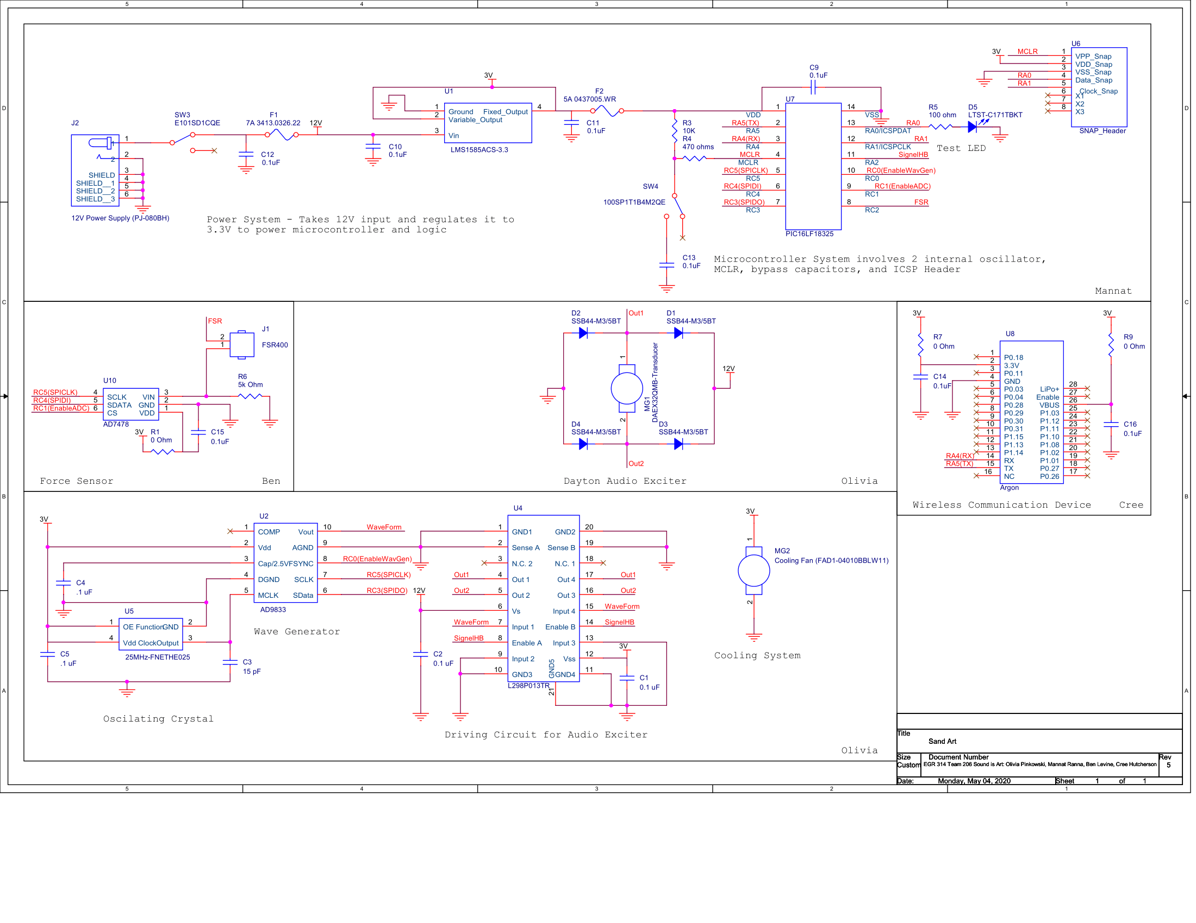

# Software Design Narrative

## Software Design

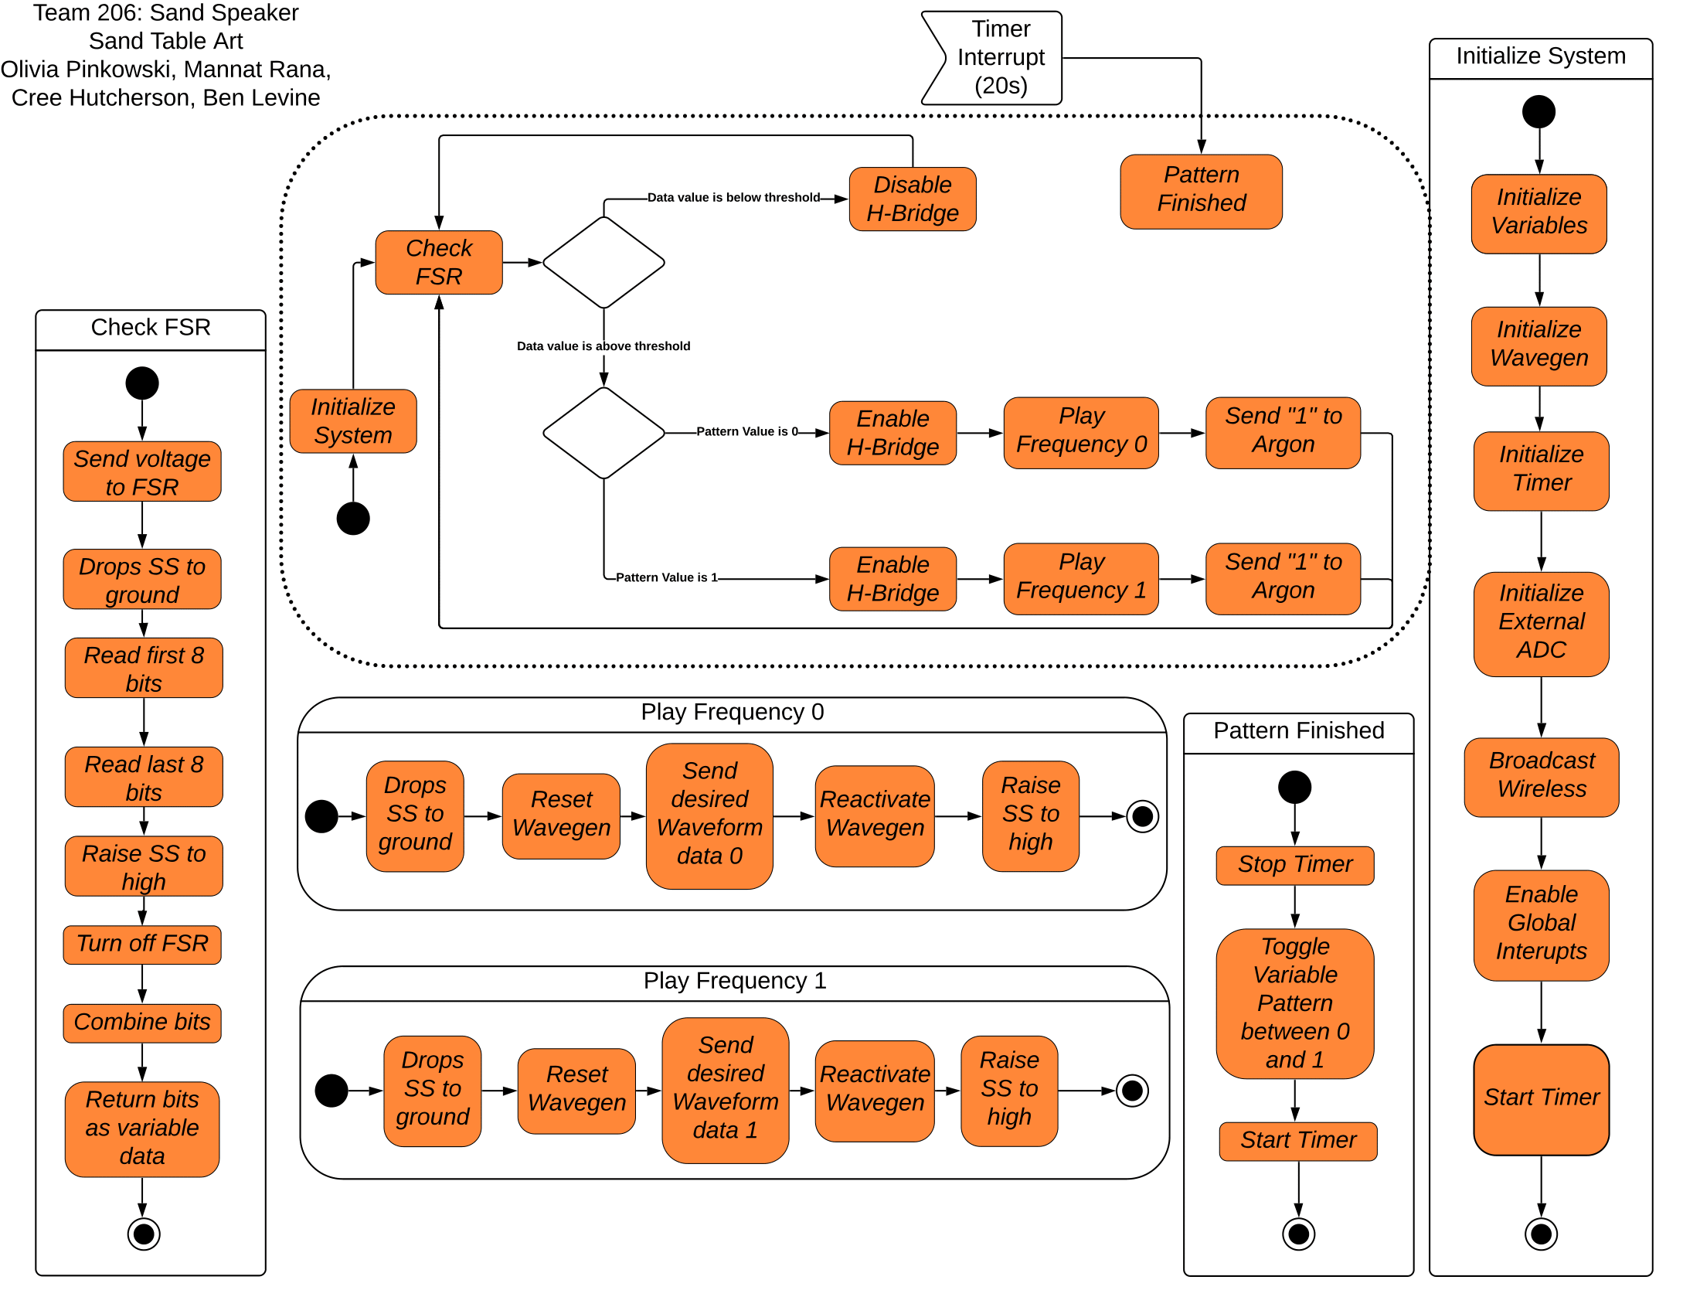

## 

## Software Design Rationale

The software begins with initializing all the peripherals and components. We must initialize SPI as it will be used to communicate with two of the subsystems, EUSART needs to be initialized to communicate with the Particle Argon, and the timer and interrupts must be initialized. A timer interrupt was utilized and occurs every twenty seconds. This is created by modifying the callback time of the timer peripheral. Whenever the timer overflows, it interrupts. When the timer interrupt occurs, the timer is reset, and a global variable called pattern is toggled between 0 and 1. The main loop begins with reading the data from the force sensor. To read the force sensor, the PIC microcontroller sends out 3.3V out of a GPIO pin to the input pin of the FSR. Depending on the force applied to the sensor, the voltage coming out of the FSR will vary and this is what is captured by the external ADC. The external ADC then converts the value of the incoming voltage. To check the external ADC, the SS pin is grounded. The output of the external ADC is in 16 bits, with 4 leading zeroes and 4 ending zeros. The needed information is in the middle 8 bits. However, the PIC microcontroller only can handle 8 bits in one transmission. To work past this limitation, the first 8 bits are stored in a variable, and the second 8 bits is read back-to-back to the first and stored in a separate variable. The SS is set back to high, and the power being sent to the FSR is turned off. Then the two variables containing the information are modified to create a new variable that contains the middle 8 bits of the important information. To determine whether the lid is open or closed, this new data variable is compared to a threshold value found through testing. If the value is lower, then the lid is considered open. If the lid is open, then the plate should not vibrate as there is nothing to contain the mess. To do this, the enable pin of the H-Bridge is tied to a GPIO on the PIC microcontroller. Using this connection, the H-Bridge can be disabled, thus turning off the audio exciter and preventing any vibrations. If the value is higher, then that means the lid is closed and the H-Bridge is enabled which means any frequency sent through it will be played by the audio exciter. The waveform generator is programmed via SPI by writing to its registers. The waveform generator also requires transmissions via 16 bits, which creates the same problem that existed with the external ADC: the PIC microcontroller can only handle 8 bits. Luckily, the datasheet of the waveform generator detailed exactly how to handle this issue, and the solution is two send the data as 2 transmissions of 8 bits each, but keep the clock high in between transmissions. Therefore, the SPI peripheral was modified to operate in SPI Mode 2, and this problem was solved. The waveform generator is programmed in 5 transmissions, the first resets and locks the component, the second sends the type of wave desired i.e. triangular, sinusoidal, or square, the next one writes the frequency, the fourth writes the phase (zero in this case), and the the last unlocks the component with the new waveform uploaded. Depending on the value of the pattern set by the timer interrupt, the waveform will be different.

# Mechanical Design Narrative

## Mechanical Design Rationale

Our design began with the full intention of finishing and producing a complete prototype. Unfortunately due to the circumstances surrounding the COVID-19 pandemic our team was unable to complete this goal. The final prototype of the semester includes a cardboard tray to collect all the fallen sugar/sand, with the vibrating plate placed off to one side and the electronics box placed on the other side of the tray. For the final prototype, we were unable to secure the pedestal with the audio exciter to the tray and appropriately apply shock absorbers. This was due to the fact that the cardboard we used was not structurally sound enough to mount/drill to. As a result, during demonstrations we held the pedestal down by hand. The device has approximate dimensions of 1’x2’ and this size will be maintained for the end product. We were unable to create a clear lid for the device to dampen the noise emitted and contain the device within itself. As a result, our final prototype consists of a tray leaving the force sensor to float, instead of being mounted to the lid perimeter. This also means that a person has to compress the sensor for demonstration purposes. The chladni plate and audio exciter are attached to a bottle filled with water via hot glue to act as the stable mounting pedestal for the device. This also provided us a handle to hold while testing so the plates would remain stationary. Sugar was used instead of sand for the prototype because it was more available than sand. Any material can be used as long as it is consistent/homogeneous throughout, like sugar, salt, and fine sand. The transmitted frequencies were able to create the images in the sugar and properly demonstrate the design functionality. The tray does have it’s advantages, it allows for easy cleanup. All the user needs to do is wipe the sugar off the plate with a paper towel into the tray, pick the device up out of the tray, then dump the tray into the trash or a to-go baggie. Cleaning the plate is also easier, as the user can simply spray the plate with isopropyl alcohol and then wipe with a paper towel. The current design allows for two different patterns to display from two different frequencies (which are audible) and promotes learning and connections between the patterns and the frequency.

## Project in Context

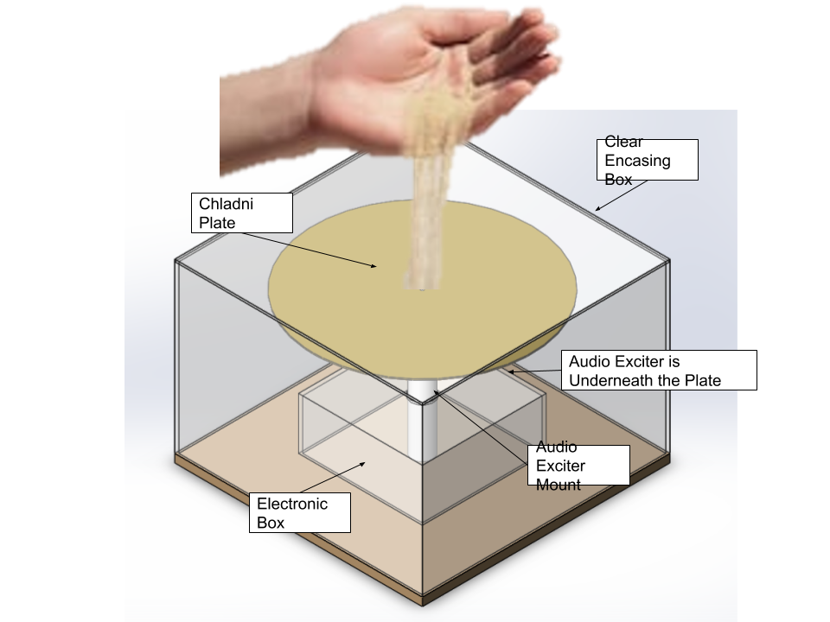

## Project Photos

***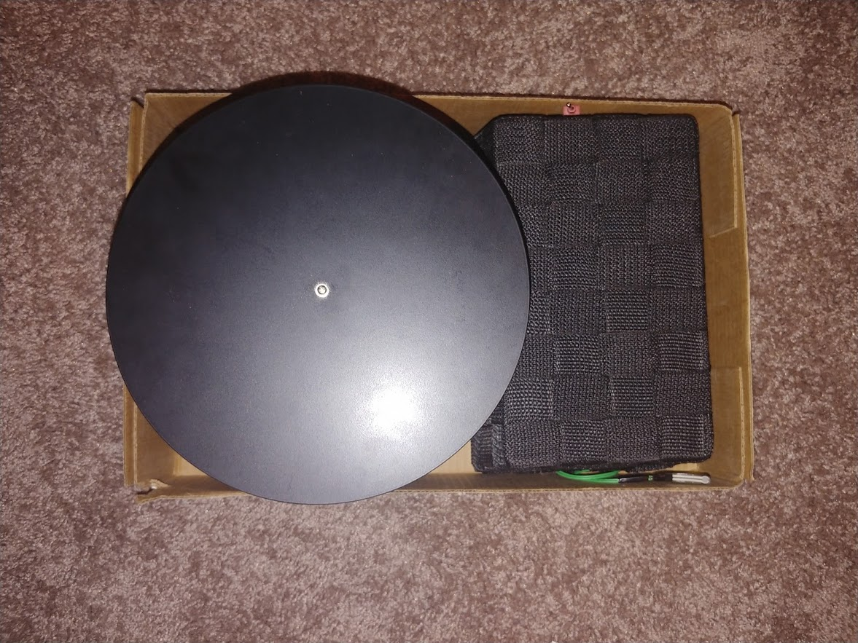* 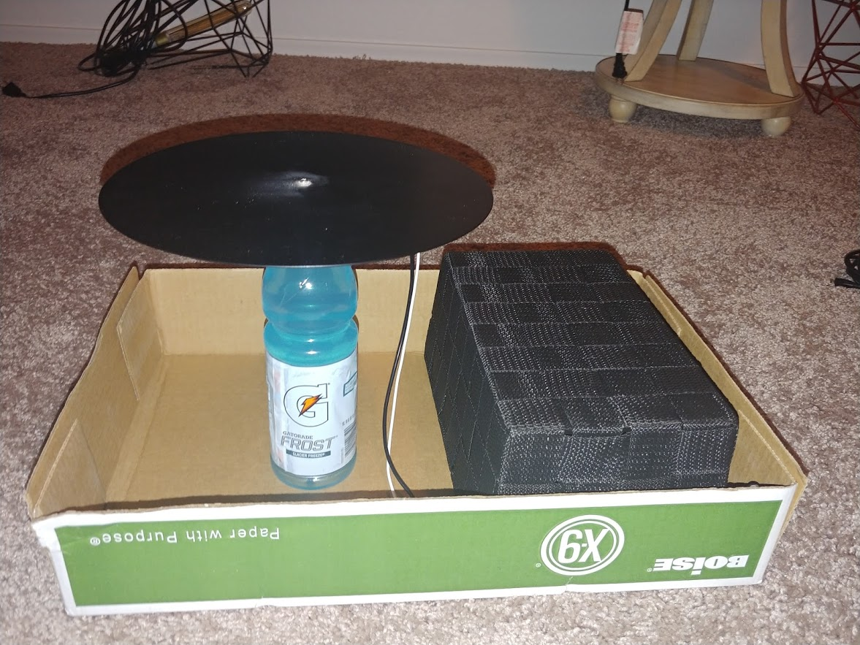**

# Version 2.0 and Lessons Learned

## Hardware Design

The hardware design could be greatly improved in several ways. The first way is to add a some sort of controller to the system. This could be a button, a slider, or a Particle Argon function connected with the wireless device. This controller could be used for several interesting and interactive features such as being able to choose patterns, or even as an override allowing the user to vibrate the plate even with the lid open. Another improvement that could be made is to get a PIC microcontroller with more GPIO pins and using the extra GPIO pins to control the fan. Another addition to the cooling system would include the addition of a temperature sensor to then determine when and how much the fan is driven. The PIC microcontroller could receive a reading from a temperature sensor then adjust the fan speed accordingly; it would then be powered via a PWM signal which would vary with the magnitude of the temperature. As of right now, the fan would always be on. Since we did not experience overheating the fan was never attached. This would be a huge drain on the power system if left unchanged. By controlling the fan using a PWM, it prevents the fan from being constantly powered, thus lowering the strain on the power infrastructure. Another tweak to the hardware design, that would be helpful, could include utilizing a wider trace width on the PCB. There could also be two fans. The current fan is used to cool the H-Bridge, but a second fan could be implemented to cool the 3.3V regulator, which also has its own heating issues with extended use. The device pulls anywhere from 5-7A at a given moment, and the trace widths were not high enough to accommodate that amount of current. Larger trace widths would allow for more current draw without any damage to the board. Finally, a PIC microcontroller that is power powerful in terms of the amount of data it can handle would be very helpful. Having an external oscillating crystal with a larger frequency could also be helpful. With a higher frequency, timing precision goes up, and several more peripherals could have been added that could have made the project run much more smoothly.

## Software Design

The software design could have several added features that could prevent any future bugs and help improve the stability of the device. One of these features could be to create a EUSART interrupt that occurs every time a data is sent to the PIC microcontroller from the Particle Argon. Instead of relying on an uncontrollable timer, this EUSART interrupt could be created by a user pressing a button on their phone through the Particle application. The button would be associated with a value that the Particle Argon would send the PIC microcontroller. The PIC microcontroller would then drop whatever it's doing, match the incoming number to a frequency, and have that frequency played. This would enable the user to have some control over the device. Another improvement that could be made to the software would be to add more patterns. Because of the remote nature of the project, only two frequencies that generated two clear patterns were found. In a future version with more time, there would be many more frequencies that span more magnitudes until the MHz. Currently the only two frequencies are in the Hz. With a larger number and range of frequencies, the users can experience and learn more about waves and sound by being able to visualize the larger range through the patterns developed in the sand. Finally, the code should also use the LED to play a bigger role in showing the user what is going on, as the LED could also blink at the same frequency as the audio exciter so that the user can experience that frequency in multiple visual platforms.

## Mechanical Design

The final structure of the design should be created from a clear material so viewers can view the patterns as they are created. Due to limitations, the prototype is made from cardboard and open on all sides. This openness allows for someone to place their hand in the system when it is in operation and allows the sugar to occasionally fly out of the box. The chladni plate should be mounted directly to the base of the design and have proper shock-absorbers to reduce the movement of the box itself and focus all the vibrations from the audio exciter to creating the patterns. The final prototype does not have proper shock-absorbers and the patterns were displayed inconsistently. Part of this inconsistency is a result of the plate being at an angle and loosely placed in the box. A solid connection between the vibrating plate and base of the device would alleviate some of these issues. Another problem that arose from the final prototype was that the force sensor ripped on testing day because it was not mounted to the side of the box, as the wires connecting it to the PCB twisted. Ideally, the force sensor would be mounted and secured to the lip of the box. Since this was not the case the rip resulted and caused the project to become inoperable with the current code. There should also have been a separate enclosure for the electronic components on the project. Occasionally, the sugar would vibrate off of the plate and land on the PCB, which had the potential to damage the project and make a mess.

## 

## Lessons Learned

1. Have similar hardware platforms when trying to debug remotely.
2. Have **BOTH** DIP and SMD components.
3. Make sure that MCLR on the PIC Microcontroller is configured properly.
4. Make sure to check for shorts everytime after placing individual components.
5. Double Check your pad footprints, sizes, and pin layouts.
6. Always check for continuity issues before placing components.
7. Understand the differences between the communications protocols before trying to program them.
8. Use an external oscillating crystal so that timing functions are more accurate and precise especially when using SPI.
9. Make sure to start the timer when using the internal timer peripheral in MCC.
10. Make sure to double-check that the registers in the MCC Peripheral Module menu match what they should be.
11. Program in small steps so that going back to a functional state is much easier.
12. Make sure that cut traces are fully cut and don’t just appear to be cut. Check continuity to be sure.
13. Less solder is more. You don’t need to glob it up, a little goes a long way.
14. Always solder in well lit areas.

## 

## Recommendations for Future Students

Read up on SPI, I2C, and UART, these are communications protocols that are extremely powerful but also extremely limited in their usage. Practice soldering so that you are more confident when it comes time to solder your boards. When soldering, start with the reflowed parts, then go from smallest to largest in components. When designing your PCBs, make sure that all ground islands are resolved before you send them to manufacturing and verify that all your net aliases connect where you expect them to (i.e. check spelling). Maximize your copper usage, there is no reason to waste copper. Also, make sure to go to as many office hours as possible, the TA’s have all been through the same hardships as you, and generally at least one will have encountered the same if not similar problem you may be running into. Make sure then when using connectors, the wires you use are long enough so that you don’t run into a wire length issue when creating your mechanical design. Also, read up on interrupts, while complicated, they are also very powerful and can solve all the problems you may have when trying to change something on the edge of a dime.

# Appendix

## A. Benchmarking

|  |  |  |  |  |
| --- | --- | --- | --- | --- |
| **Solution** | **Description** | **Pros** | **Cons** | **Cost** |
| [SoundScribe Plus](https://www.etsy.com/shop/CymaticsLab) | Explore Cymatics wirelessly. Bluetooth Chladni Plate for science, art, and music. Can control sand with different desired frequencies. | * Easy to use * Premade personalized application * Portable | * Fairly expensive * Not the cleanest or most professional build * No containment for the sand * Does not prevent mess | $200 |
| [3B Scientific U56006 Metal Square Chladni Plate](https://www.amazon.com/3B-Scientific-U56006-Square-Chladni/dp/B005LY3NZY) | Metal plate for generating acoustically exciting figures in media such as fine dry sand as in the experiment by Chladni | * Easy to use * Pre-assembled * Comes with cord for external vibrator * Does not require external power | * Requires external vibrator * No way to contain the mess * Easily damaged * Cannot be used with music * Not wireless | $43 |
| [beFree Bluetooth Speakers](https://www.generixllc.com/products/befree-sound-multimedia-sound-reactive-color-changing-led-and-dancing-water-bluetooth-computer-speakers-1?_pos=2&_sid=2ef94cbf1&_ss=r) | The beFree Bluetooth Speakers visualize the sound by having LED’s change and water dance according to the music. | * Wireless/Bluetooth enabled * Easy to pair and control * Visualize sound in multiple ways * No mess | * No human interaction * Low battery life * No customizability | $35 |
| [Sylvania SP349 Water Dancing Bluetooth Tower Speaker](https://www.walmart.com/ip/Sylvania-SP349-Water-Dancing-Bluetooth-Tower-Speaker/55577364) | The Sylvania speaker towers help the user visualize the music through the changing water in its tank. | * Bluetooth enables * Well built * Affordable | * Not easily portable * Water dances based on volume * Requires external power | $60 |
| [Sharper Image Wireless LED Party Speaker with LED Tripod + Mic](https://www.jcpenney.com/p/sharper-image-wireless-led-party-speaker-with-led-tripod-mic/ppr5007904461?pTmplType=regular) | This speaker visualizes the sound with LEDs. It also comes with a microphone for singing. | * Comes with a mic * High volume capabilities * Wireless * Portable * Has a tripod stand | * Costly * No customizability * Requires an external power source | $100 |

## B. Bill of Materials

|  |  |  |  |  |  |  |  |  |  |  |  |  |  |  |  |  |
| --- | --- | --- | --- | --- | --- | --- | --- | --- | --- | --- | --- | --- | --- | --- | --- | --- |
| **Part Name/**  **Description** | **Unit Quantity** | **Unit Prototype Cost** | **Total Prototype Cost** | **Unit Production Cost** | **Total Production Cost** | **Manufacturer** | **Manufacturer Part #** | **Supplier** | **Supplier Part #** | **# Ordered** | **Date Ordered** | **# Received** | **Surplus** | **Schematic Reference Designators** | **Cost** | **URL** |
| **0 ohm Resistor** | 5 | $0.10 | $0.50 | $0.00 | $0.02 | Stackpole Electronics Inc | RMCF0805ZT0R00 | Digi-Key | RMCF0805ZT0R00CT-ND | 0 | Mar 4 | 15 | 15 | R1, R7, R8 | $0.00 | [Link](https://www.digikey.com/products/en?keywords=RMCF0805ZT0R00CT-ND) |
| **100 Ohm Resistor** | 1 | $0.10 | $0.10 | $0.00 | $0.00 | Stackpole Electronics Inc | N/A | Peralta Studio | N/A | 3 | N/A | 3 | 2 | R5 | $0.30 | [Link](https://www.digikey.com/product-detail/en/vishay-bc-components/PR02000201001JR500/PPC1-0KW-2TR-ND/596130) |
| **10K Ohm Resistor** | 1 | $0.10 | $0.10 | $0.00 | $0.00 | Stackpole Electronics Inc | N/A | Peralta Studio | N/A | 3 | N/A | 3 | 2 | R3 | $0.30 | [Link](https://www.digikey.com/product-detail/en/stackpole-electronics-inc/CF14JT10K0/CF14JT10K0TR-ND/1741265) |
| **12V 7A DC Power Supply** | 1 | $15.99 | $15.99 | $15.99 | $15.99 | HUI KE Yuan | B07X9ZL7HF | Amazon | B07X9ZL7HF | 1 | Feb 29 | 1 | 0 | N/A | $15.99 | [Link](https://www.amazon.com/100V-240V-Converter-Transformer-5-5x2-5mm-Security/dp/B07X9ZL7HF/ref=sr_1_1?dchild=1&keywords=B07X9ZL7HF&qid=1588590256&sr=8-1) |
| **3.3V 5A Regulator** | 1 | $2.85 | $2.85 | $1.33 | $1.33 | Texas Instruments | LMS1585ACS-3.3/NOPB | Digi-Key | LMS1585ACS-3.3/NOPB-ND | 4 | Mar 6 | 4 | 3 | U1 | $11.40 | [Link](https://www.digikey.com/products/en?keywords=LMS1585ACS-3.3%2FNOPB-ND) |
| **470 Ohm Resistor** | 1 | $0.10 | $0.10 | $0.00 | $0.00 | Stackpole Electronics Inc | N/A | Peralta Studio | N/A | 3 | N/A | 3 | 2 | R4 | $0.30 | [Link](https://www.digikey.com/product-detail/en/riedon/PF2472-5KF1/696-1116-5-ND/2447866) |
| **5K Ohm Resistor** | 1 | $0.10 | $0.10 | $0.00 | $0.00 | Stackpole Electronics Inc | N/A | Peralta Studio | N/A | 3 | N/A | 3 | 2 | R6 | $0.30 | [Link](https://www.digikey.com/product-detail/en/riedon/PF2472-5KF1/696-1116-5-ND/2447866) |
| **ADC** | 1 | $2.89 | $2.89 | $1.80 | $1.80 | Analog Devices | AD7478ARTZ-500RL7 | DigiKey | 584-AD7478ARTZ-500R7 | 2 | Mar 6 | 2 | 1 | U10 | $5.78 | [Link](https://www.digikey.com/product-detail/en/analog-devices-inc/AD7478ARTZ-500RL7/AD7478ARTZ-500RL7TR-ND/995461) |
| **Barrel Connector** | 1 | $2.41 | $2.41 | $1.07 | $1.07 | CUI Devices | PJ-080BH | Digi-Key | CP-080BHCT-ND | 3 | Mar 6 | 3 | 2 | J2 | $7.23 | [link](https://www.digikey.com/products/en?keywords=CP-080BHCT-ND) |
| **Blue LED 3.3V 0805** | 1 | $0.48 | $0.48 | $0.09 | $0.09 | Lite-On Inc. | LTST-C171TBKT | Digi-Key | 160-1645-1-ND | 3 | Mar 6 | 3 | 2 | D5 | $1.44 | [Link](https://www.digikey.com/products/en?keywords=160-1645-1-ND) |
| **Bypass Cap (0.1uF)** | 10 | $0.10 | $1.00 | $0.02 | $0.20 | N/A | N/A | Peralta Studio | N/A | 0 | N/A | 20 | 10 | C1, C2, C4, C5, C9, C10, C11, C12, C14, C15 | 0 | [Link](https://www.digikey.com/product-detail/en/murata-electronics/GRM033R61A104ME15D/490-5405-2-ND/2175191) |
| **Chladni Plate** | 1 | $52.02 | $52.02 | $52.02 | $52.02 | 3B Scientific | U56005 | Amazon | 77526894000 | 1 | Mar 6 | 1 | 0 | N/A | $52.02 | [Link](https://www.amazon.com/gp/slredirect/picassoRedirect.html/ref=pa_sp_atf_aps_sr_pg1_1?ie=UTF8&adId=A02721653GP1VYGZ2JZWE&url=%2F3B-Scientific-U56005-Circular-Chladni%2Fdp%2FB005LY3OO4%2Fref%3Dsr_1_1_sspa%3Fcrid%3DWFVB67ETUNDI%26dchild%3D1%26keywords%3Dchladni%2Bplate%26qid%3D1588590433%26sprefix%3Dchlad%252Caps%252C211%26sr%3D8-1-spons%26psc%3D1&qualifier=1588590433&id=1122302082741844&widgetName=sp_atf) |
| **Cooling Fan** | 1 | $5.83 | $5.83 | $4.28 | $4.28 | Qualtek | FAD1-04010BBLW11 | Digi-Key | Q608-ND | 2 | Mar 6 | 2 | 1 | MG2 | $11.66 | [Link](https://www.digikey.com/products/en?keywords=Q608-ND) |
| **Dayten Audio Transducer** | 1 | $24.81 | $24.81 | $24.81 | $24.81 | Dayton Audio | DAEX32QMB-4 | Amazon | 295-264 | 1 | Mar 6 | 1 | 0 | MG1 | $24.81 | [Link](https://www.amazon.com/Dayton-Audio-DAEX32QMB-4-Quad-Exciter/dp/B071LH266V/ref=sr_1_4?crid=WF6YJ5B1YERD&dchild=1&keywords=dayton+audio+transducer&qid=1588590467&sprefix=dayton+audio+tran%2Caps%2C212&sr=8-4) |
| **Diodes** | 4 | $0.40 | $1.60 | $0.15 | $0.60 | Vishay Semiconductor Diodes Division | SSB44-M3/5BT | Digi-Key | SSB44-M3/5BTGICT-ND | 12 | Mar 6 | 12 | 8 | D1, D2, D3, D4 | $4.80 | [Link](https://www.digikey.com/products/en?keywords=SSB44-M3%2F5BTGICT-ND) |
| **Filter Cap (15pF)** | 1 | $0.28 | $0.28 | $0.07 | $0.07 | Yageo | CC0805FRNPO9BN150 | Digi-Key | 311-4165-1-ND | 6 | Mar 6 | 6 | 5 | C3 | $1.68 | [Link](https://www.digikey.com/products/en?keywords=311-4165-1-ND) |
| **FUSE 7A 63VDC 1206** | 1 | $0.52 | $0.52 | $0.24 | $0.24 | Schurter Inc. | 3413.0326.22 | Digi-Key | 486-1684-1-ND | 4 | Mar 6 | 4 | 3 | F1 | $2.08 | [Link](https://www.digikey.com/products/en?keywords=486-1684-1-ND) |
| **FUSE 5A 35VDC 1206** | 1 | $1.20 | $1.20 | $0.54 | $0.54 | Littelfuse Inc. | 0437005.WR | Digi-Key | F2890CT-ND | 4 | Mar 6 | 4 | 3 | F2 | $4.80 | [link](https://www.digikey.com/products/en?keywords=F2890CT-ND) |
| **H-Bridge** | 1 | $5.83 | $5.83 | $3.65 | $3.65 | STMicroelectronics | L298P013TR | Digi-Key | 497-3624-1-ND | 4 | Mar 6 | 4 | 3 | U4 | $23.32 | [Link](https://www.digikey.com/products/en?keywords=497-3624-1-ND) |
| **Heat Sink** | 3 | $2.41 | $7.23 | $1.61 | $4.83 | Wakefield-Vette | 658-60ABT1E | Digi-Key | 345-1108-ND | 6 | Mar 6 | 6 | 3 | N/A | $14.46 | [Link](https://www.digikey.com/product-detail/en/wakefield-vette/658-60ABT1E/345-1108-ND/2643561) |
| **Oscillating Crystal** | 1 | $1.10 | $1.10 | $0.76 | $0.76 | Diodes Incorporated | FNETHE025 | Digi-Key | FNETHE025CT-ND | 3 | Mar 6 | 3 | 2 | U5 | $3.30 | [Link](https://www.digikey.com/products/en?keywords=FNETHE025CT-ND) |
| **Particle Argon** | 1 | $27.00 | $27.00 | $27.00 | $27.00 | Particle | ANT-FLXV2 | Particle | ANT-FLXV2 | 0 | Mar 6 | 4 | 3 | U8 | 0 | [Link](https://store.particle.io/products/argon?utm_term=&utm_campaign=Dynamic+Search+Ads+-+S8&utm_source=adwords&utm_medium=ppc&hsa_grp=67675299738&hsa_acc=5060272854&hsa_tgt=dsa-835611334005&hsa_kw=&hsa_src=g&hsa_mt=b&hsa_cam=1697512981&hsa_ver=3&hsa_ad=329924078356&hsa_net=adwords&gclid=EAIaIQobChMIud6F4Yia6QIVQSCtBh2GQwfoEAAYASAAEgKf-fD_BwE) |
| **PIC16F18325** | 1 | $0.98 | $0.98 | $0.71 | $0.71 | Microchip | PIC16F18325 | Microchip | PIC16F18325 | 12 | Feb 18 | 12 | 11 | U7 | $11.76 | [Link](https://www.microchip.com/wwwproducts/en/PIC16F18325) |
| **Resistive Sensor** | 1 | $5.95 | $5.95 | $4.76 | $4.76 | Interlink | 400 | Pololu | 1695 | 3 | Mar 6 | 3 | 2 | J1 | $17.85 | [Link](https://www.pololu.com/product/1695) |
| **Screw Terminal** | 1 | $7.98 | $7.98 | $0.16 | $0.16 | Phoenix Contact | 1711725 | Amazon | 710560354139 | 1 | Mar 6 | 1 | 0 | N/A | $7.98 | [Link](https://www.amazon.com/Pieces-Pinch-Mount-Terminal-Connector/dp/B01MT4LC0F/ref=sr_1_8?keywords=screw+terminal&qid=1583393749&sr=8-8) |
| **Toggle Switch 5A 120V** | 1 | $1.93 | $1.93 | $1.09 | $1.09 | E-Switch | 100SP1T1B4M2QE | Digi-Key | EG2355-ND | 4 | Mar 6 | 4 | 3 | SW4 | $7.72 | [link](https://www.digikey.com/products/en?keywords=EG2355-ND) |
| **Toggle Switch 7.5A 125V** | 1 | $5.97 | $5.97 | $4.12 | $4.12 | C&K | E101SD1CQE | Digi-Key | CKN11059-ND | 3 | Mar 6 | 3 | 2 | SW3 | $17.91 | [link](https://www.digikey.com/products/en?keywords=CKN11059-ND) |
| **Wave generator** | 1 | $10.04 | $10.04 | $5.48 | $5.48 | Analog Devices Inc. | AD9833BRMZ | Digi-Key | AD9833BRMZ-ND | 3 | Mar 6 | 3 | 2 | U2 | $30.12 | [Link](https://www.digikey.com/products/en?keywords=AD9833BRMZ-ND) |

## C. Final PCB Layout

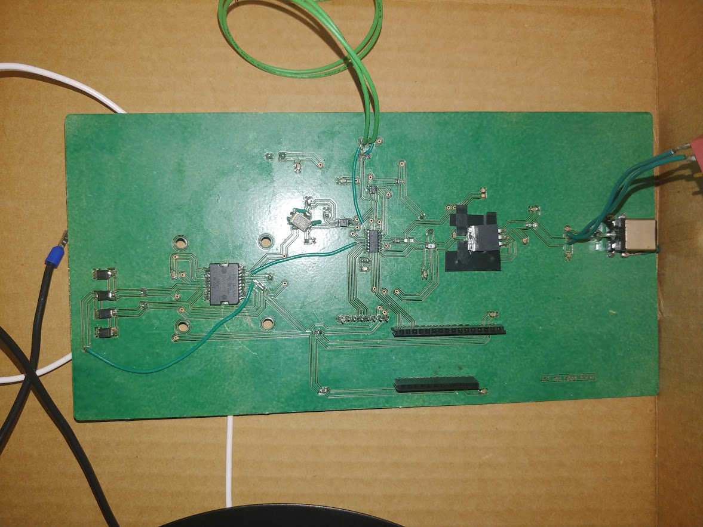

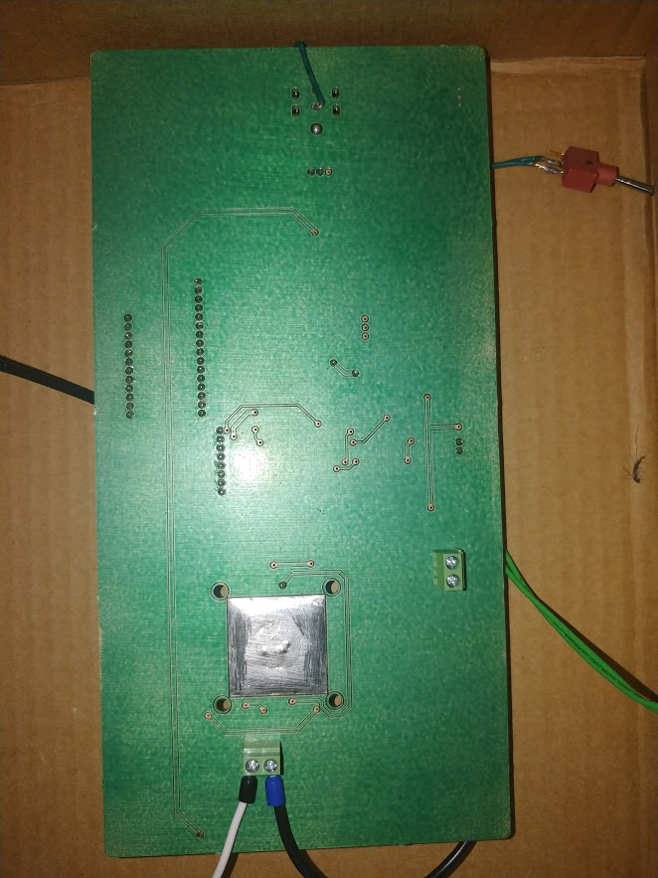

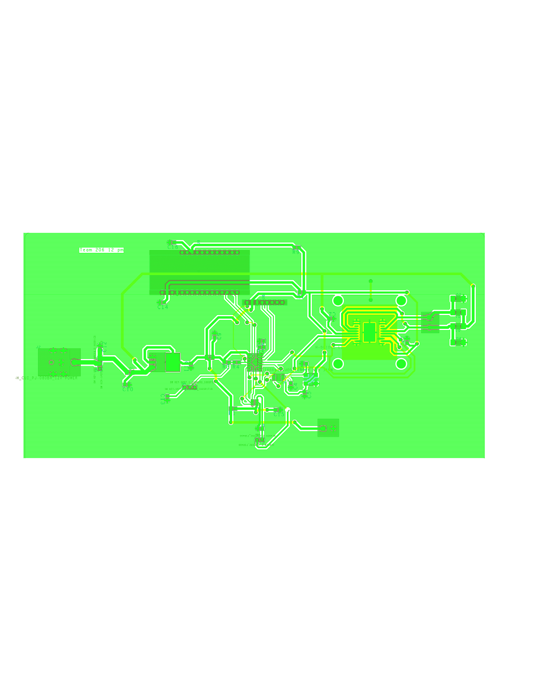

## D. All of the Code

Main.c

#include "mcc_generated_files/mcc.h"

uint8_t FSRVal;

volatile int pattern = 0;

void playfreq1(void) {

EnableWG_SetLow();

SPI1_WriteByte(0b00100001); //reset ad9833 and prepare to enter word

SPI1_WriteByte(0b00000000);

__delay_ms(0.05);

EnableWG_SetHigh();

__delay_ms(0.05);

EnableWG_SetLow();

SPI1_WriteByte(0b01010000); //write frequency 1 LSB first

SPI1_WriteByte(0b11000111);

__delay_ms(0.05);

EnableWG_SetHigh();

__delay_ms(0.05);

EnableWG_SetLow();

SPI1_WriteByte(0b01000000); //write frequency 2 MSB second

SPI1_WriteByte(0b00000000);

__delay_ms(0.05);

EnableWG_SetHigh();

__delay_ms(0.05);

EnableWG_SetLow();

SPI1_WriteByte(0b11000000); //write phase register to zero

SPI1_WriteByte(0b00000000);

__delay_ms(0.05);

EnableWG_SetHigh();

__delay_ms(0.05);

EnableWG_SetLow();

SPI1_WriteByte(0b00100000); //exit reset

SPI1_WriteByte(0b00000000);

__delay_ms(0.05);

EnableWG_SetHigh();

}

void playfreq2(void) {

EnableWG_SetLow();

SPI1_WriteByte(0b00100001); //reset ad9833 and prepare to enter word

SPI1_WriteByte(0b00000000);

__delay_ms(0.05);

EnableWG_SetHigh();

__delay_ms(0.05);

EnableWG_SetLow();

SPI1_WriteByte(0b01010000); //write frequency 1 LSB first

SPI1_WriteByte(0b11001011);

__delay_ms(0.05);

EnableWG_SetHigh();

__delay_ms(0.05);

EnableWG_SetLow();

SPI1_WriteByte(0b01000000); //write frequency 2 MSB second

SPI1_WriteByte(0b00000000);

__delay_ms(0.05);

EnableWG_SetHigh();

__delay_ms(0.05);

EnableWG_SetLow();

SPI1_WriteByte(0b11000000); //write phase register to zero

SPI1_WriteByte(0b00000000);

__delay_ms(0.05);

EnableWG_SetHigh();

__delay_ms(0.05);

EnableWG_SetLow();

SPI1_WriteByte(0b00100000); //exit reset

SPI1_WriteByte(0b00000000);

__delay_ms(0.05);

EnableWG_SetHigh();

}

float ADCRead(void) {

FSR_SetHigh();

EnableADC_SetLow();

uint8_t first = SPI1_ReadByte(); //first 8 bits of data from ADC

uint8_t second = SPI1_ReadByte(); //last 8 bits of data from ADC

EnableADC_SetHigh();

FSR_SetLow();

uint8_t reorient1 = (first & 0x0F) << 4 | (first & 0xF0) >> 4; //replace first 4 bits with last 4 bits in data

uint8_t reorient2 = (second & 0x0F) << 4 | (second & 0xF0) >> 4; //replace first 4 bits with last 4 bits in data

uint8_t data = reorient1 | reorient2; //determine the 8 bits of data sent by the ADC

return data;

}

void main(void) {

SYSTEM_Initialize();

INTERRUPT_GlobalInterruptEnable();

INTERRUPT_PeripheralInterruptEnable();

TMR2_StartTimer();

while (1) {

FSRVal = ADCRead(); //read ADC through SPI and store value

if (FSRVal < 0b00001010) {

Bridge_SetLow();

} else if (pattern == 0 && FSRVal > 0b00001010) {

Bridge_SetHigh();

EUSART_Write('1');

LED_SetHigh();

playfreq1();

}

else if (pattern == 1 && FSRVal > 0b00001010) {

Bridge_SetHigh();

EUSART_Write('1');

LED_SetLow();

playfreq2();

}

}

}

TMR2.c

#include <xc.h>

#include "tmr2.h"

volatile int pattern = 0;

/**

Section: Global Variables Definitions

*/

void (*TMR2_InterruptHandler)(void);

/**

Section: TMR2 APIs

*/

void TMR2_Initialize(void)

{

// Set TMR2 to the options selected in the User Interface

// PR2 255;

PR2 = 0xFF;

// TMR2 0;

TMR2 = 0x00;

// Clearing IF flag before enabling the interrupt.

PIR1bits.TMR2IF = 0;

// Enabling TMR2 interrupt.

PIE1bits.TMR2IE = 1;

// Set Default Interrupt Handler

TMR2_SetInterruptHandler(TMR2_DefaultInterruptHandler);

// T2CKPS 1:1; T2OUTPS 1:1; TMR2ON on;

T2CON = 0x04;

}

void TMR2_StartTimer(void)

{

// Start the Timer by writing to TMRxON bit

T2CONbits.TMR2ON = 1;

}

void TMR2_StopTimer(void)

{

// Stop the Timer by writing to TMRxON bit

T2CONbits.TMR2ON = 0;

}

uint8_t TMR2_ReadTimer(void)

{

uint8_t readVal;

readVal = TMR2;

return readVal;

}

void TMR2_WriteTimer(uint8_t timerVal)

{

// Write to the Timer2 register

TMR2 = timerVal;

}

void TMR2_LoadPeriodRegister(uint8_t periodVal)

{

PR2 = periodVal;

}

void TMR2_ISR(void)

{

static volatile unsigned int CountCallBack = 0;

// clear the TMR2 interrupt flag

PIR1bits.TMR2IF = 0;

// callback function - called every 4096th pass

if (++CountCallBack >= TMR2_INTERRUPT_TICKER_FACTOR)

{

// ticker function call

TMR2_CallBack();

// reset ticker counter

CountCallBack = 0;

}

}

void TMR2_CallBack(void)

{

// Add your custom callback code here

// this code executes every TMR2_INTERRUPT_TICKER_FACTOR periods of TMR2

if(TMR2_InterruptHandler)

{

TMR2_InterruptHandler();

}

}

void TMR2_SetInterruptHandler(void (* InterruptHandler)(void)){

TMR2_InterruptHandler = InterruptHandler;

}

void TMR2_DefaultInterruptHandler(void){

TMR2_StopTimer();

pattern = pattern + 1; //increment pattern with time

if (pattern > 1) {

pattern = 0; //reset pattern if increments above pattern number

}

TMR2_StartTimer();

}

## E. User’s Manual

### Basic operation with photos

1. Give the device Power:
   1. Plug the power cord into the wall. Ensure the device switch is off. Insert barrel connector into port on the device.

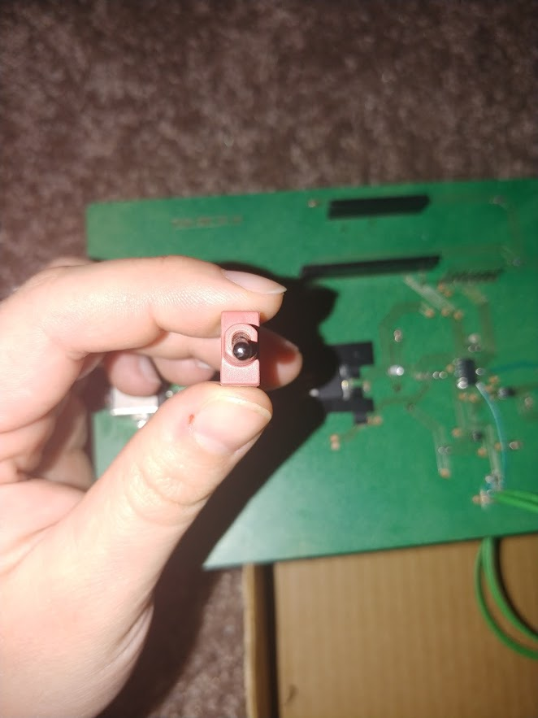 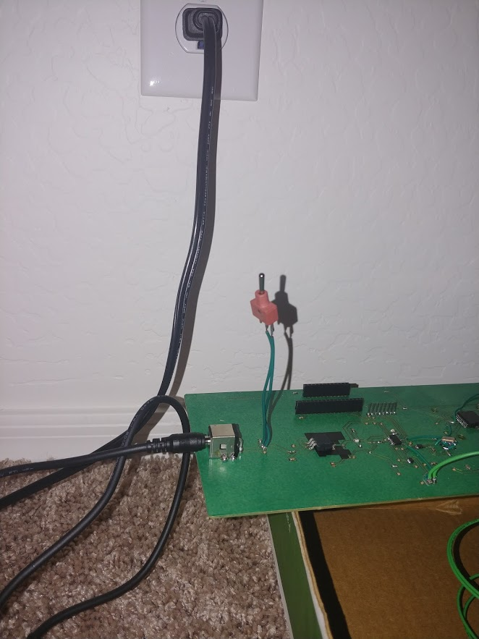

1. Add your material:
   1. Open the lid of the device. Add a tsp of your desired homogeneous material to the center of the plate.

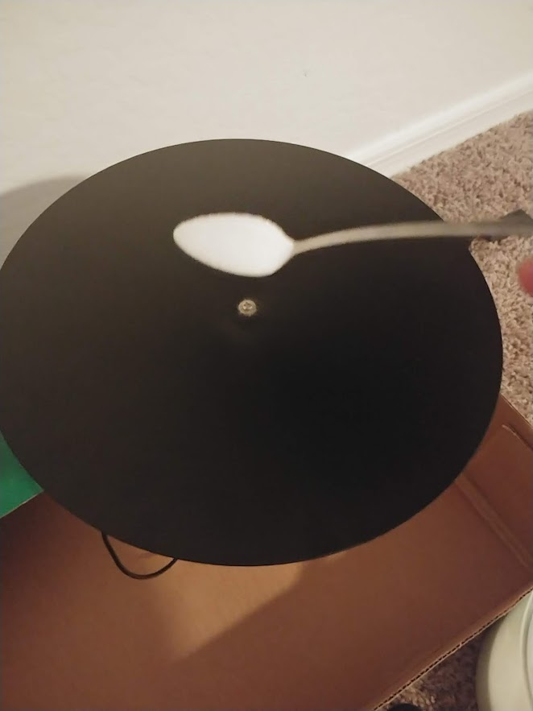 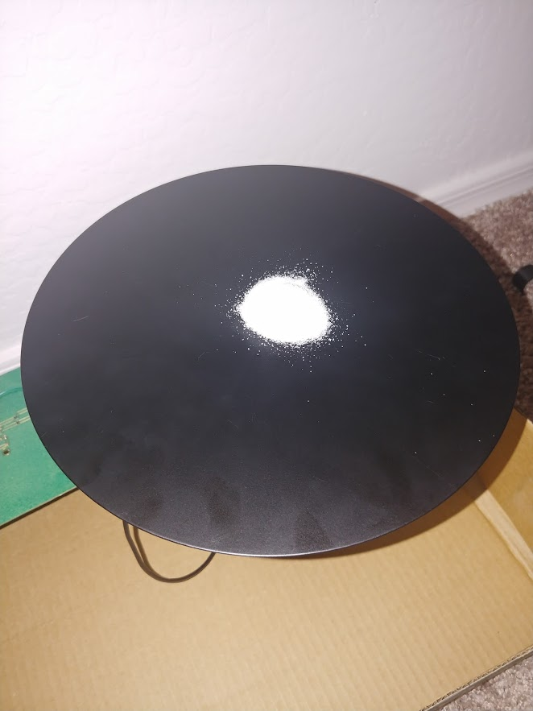

1. Begin making a Pattern
   1. Flip the switch to the on position **then** close the lid. Watch the pattern take shape before your eyes.
      1. If the lid is closed when the device is initially turned on the system will not work.

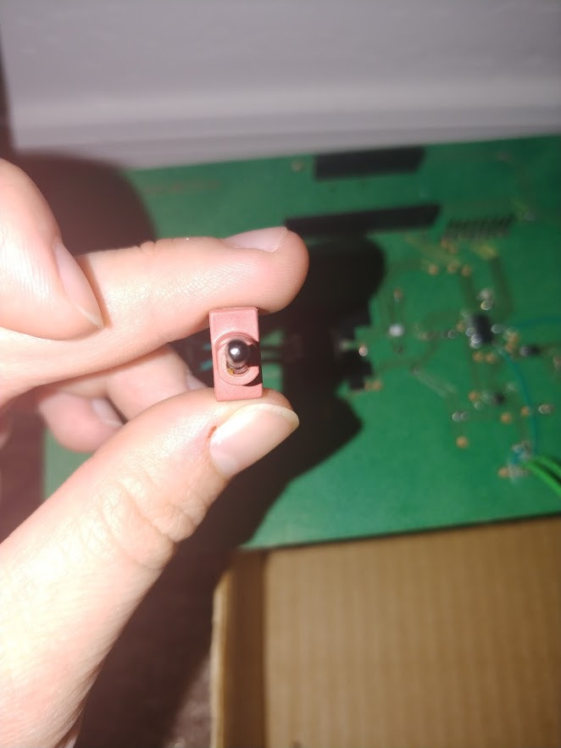 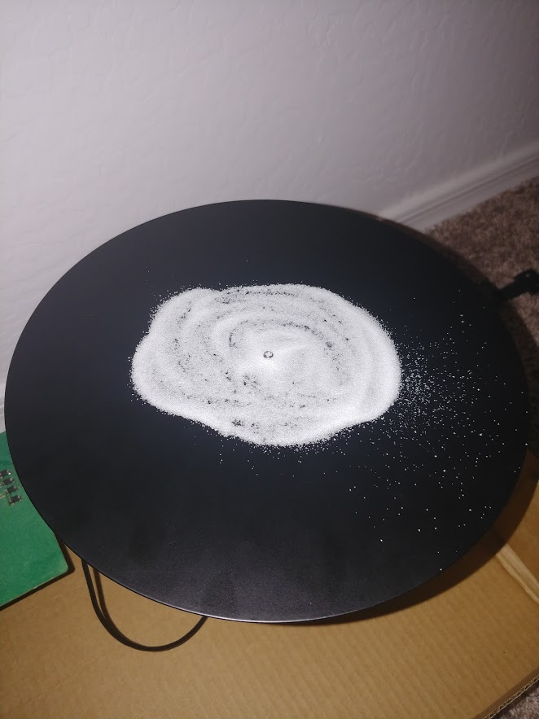

1. When finished turn the device off by toggling the switch.



### Maintenance and troubleshooting

1. You will need to clean the plate if someone touches it, as the oils in your skin will cause the material on the plate to clump and not form the images properly.
2. If the device is not operating then turn it off. Open the lid. Turn the device on. Close the lid. Your patterns should begin to form.
   1. If the device still is not operating, then the Force Sensor could have ripped and needs to be replaced.
3. The 3.3V Regulator may get hot, turn the device off in this case and allow it to fully cool.
4. If the device is not level then the patterns will be offset and distorted.

## F. CAD Model

